# Introduction

You leave your house in the morning, you get to work, and you remember that you left your bedroom light on. You think, “Great. Money wasted”. With the use of the Nosferatu system, this is no longer a problem. Nosferatu will be a direct replacement for your current lighting setup. Each of your conventional light switches will be replaced with a new network-enabled switch, giving it the ability to connect to a central hub in your home, and automate all of your home lighting.

In order to automate a given light switch in your home, that switch will be replaced with a Nosferatu switch. Each of these new “switches” will look similar to a normal light switch plate, except instead of a simply a switch sticking out, there will a few things. The most prominent will be a small dome shape, which is the front of a motion sensor. Then there will also be a button, which replaces the manual input that the original switch controlled as well as serving as a manual override to any automated commands.

Any given switch can be manually turned on and off, through the web service, which simply acts as a toggle. Each switch can be configured to turn on/off on a schedule, independent of any other switches. Finally, more complex rules can be configured to turn on/off a switch. Rules include input such as motion sensor data, time of day (such as sunrise and sunset), the status of other lights, and more.

Each switch also has a Wi-Fi chip inside of it, allowing it to network to the other switches through a centralized hub. This hub will be responsible for communicating with all the switches in your network, as well as hosting a web service that is used to do any configuration of the system. Through any Internet browser, any switch can be connected to, and then controlled through a number of inputs.

Currently there are very few existing consumer available solutions for automated lighting. Wi-Fi enabled light bulbs and the Belkin WeMo are the only real competition in the market. Even in the space of patents, where there isn’t necessarily a product yet, there are only a few, and they tend to not directly impact the space that Nosferatu fills.

Wi-Fi enabled light bulbs like the LumenBulb[1] have been the most common to date. Their main drawback, however being that any time a bulb burns out, the whole light needs to be replaced. Given that each light costs many times more than a normal light bulb, this can become expensive very quickly. This also become unnecessarily expensive when a single switch turns on more than a single light bulb, or actually impossible if the bulbs being controlled are more esoteric and not in a size where Wi-Fi light bulbs are sold. Even ignoring all of these issues, they tend to be sold singularly, so any attempt at controlling the lights as a whole system, rather than individually essentially requires a lot of manual setup.

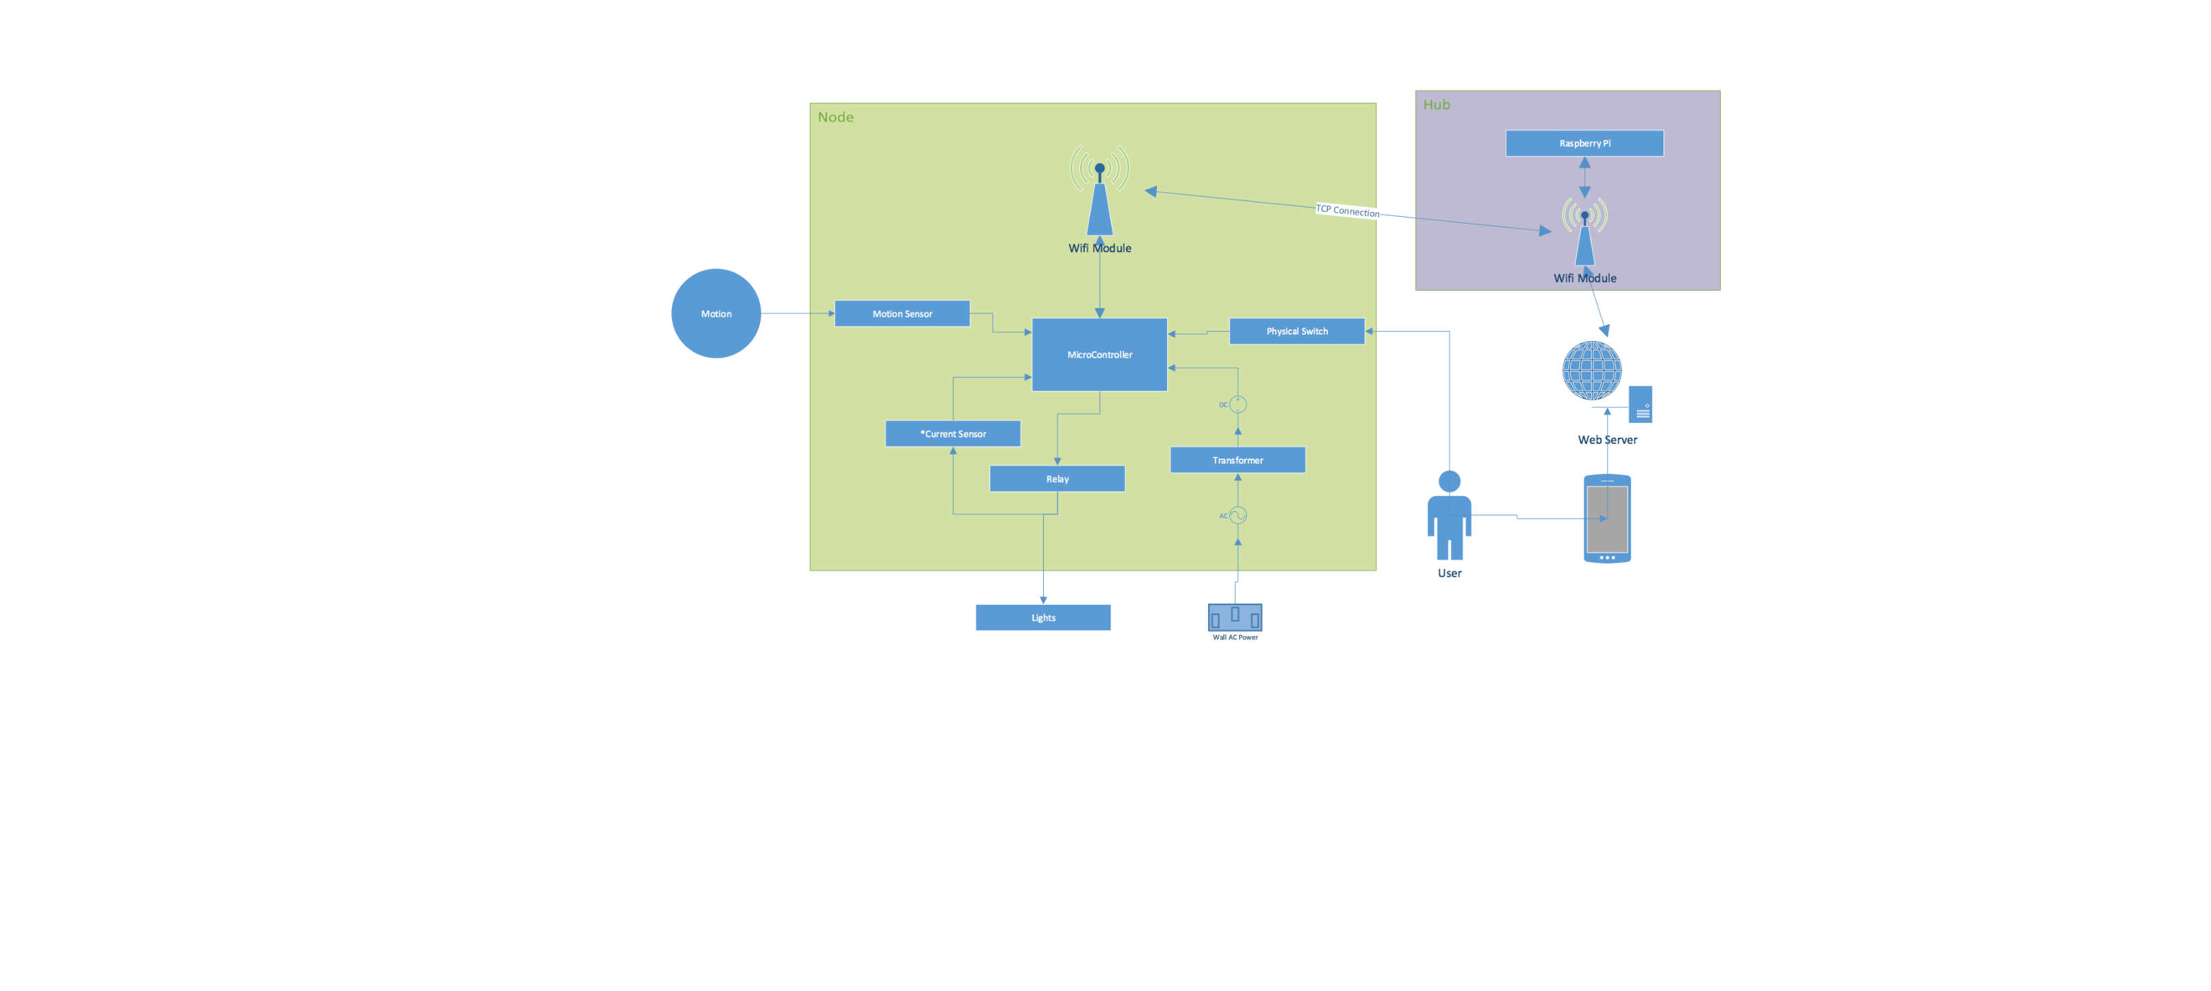For in wall solutions, the Belkin WeMo[2] is the only real similar product on the market. However, the WeMo is also a large step backwards from Nosferatu. On the hardware side there is not much different, other than the WeMo’s lack of a motion sensor. Belkin does sell a motion sensor that is compatible the WeMo, however it is sold separately (and when paired with the WeMo, costs nearly twice as much as Nosferatu’s prototypes), and does not fit into the wall unit itself, and needs to be placed on something nearby. On the software side, while they do have the ability to control the unit on a schedule, there is much less the WeMo can do with rules; basically limiting it to time based automation. Finally, by default the WeMo is unable to be controlled through anything but their proprietary app. Third parties have found ways around this, and created self-hosted solutions, however Nosferatu is built with this in mind so that out of the box, it can be interacted with through any device that can access the internet.

References

[1] <http://www.lumenbulb.net/>

[2] <http://www.belkin.com/us/Products/home-automation/c/wemo-home-automation/>